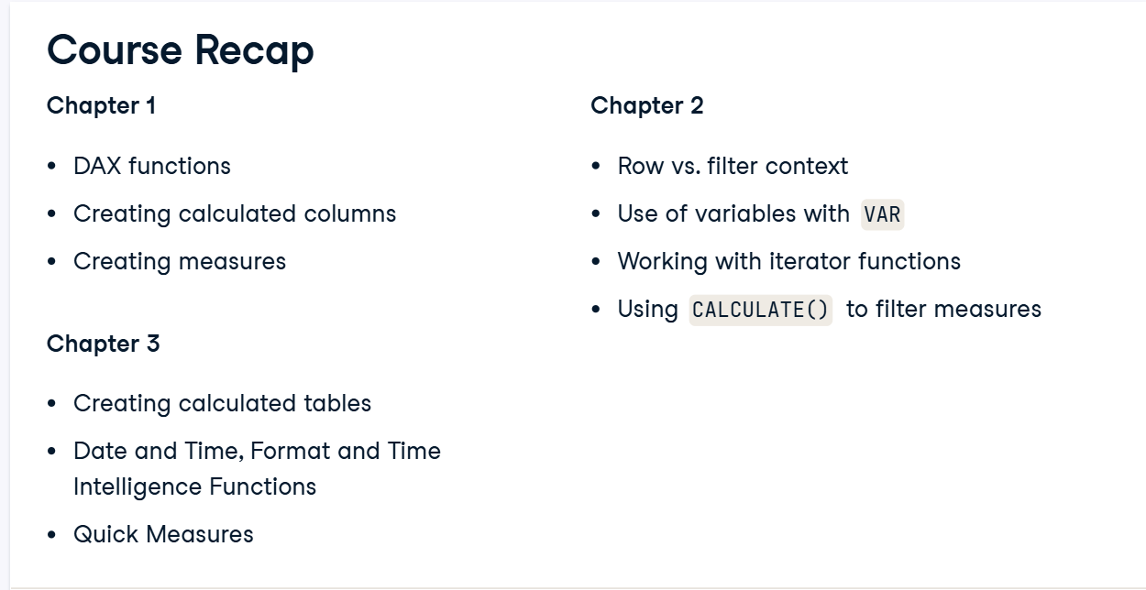**Data Analyst in Power BI Data-Camp 2025**

**Section 2: Introduction to DAX in Power BI**

1. **Get Started with DAX**

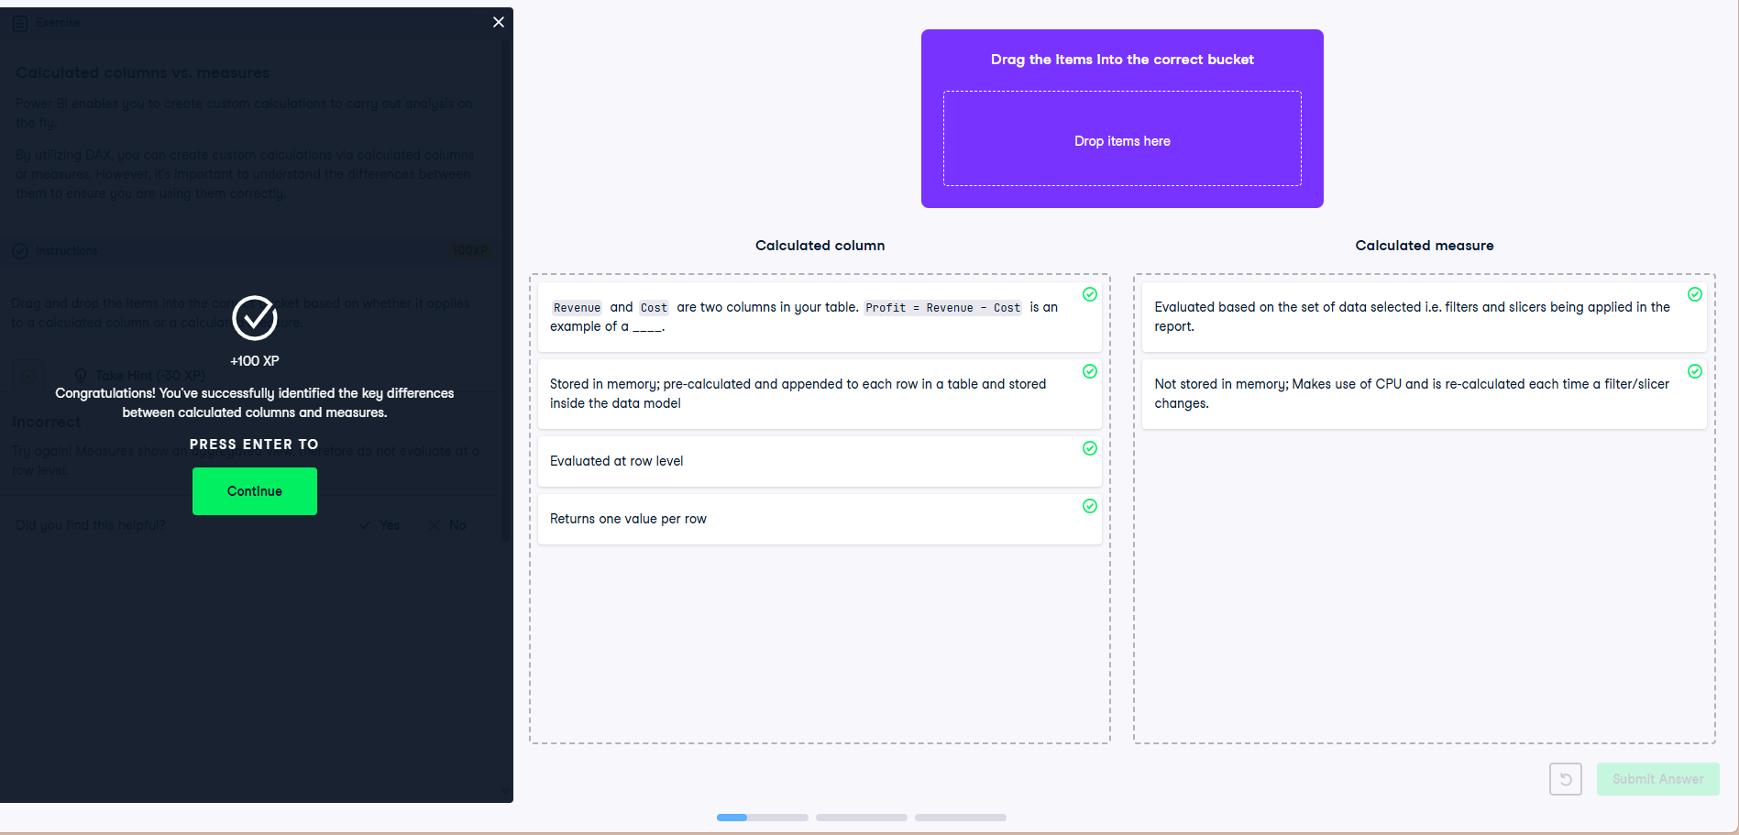

**Exercise 1.1**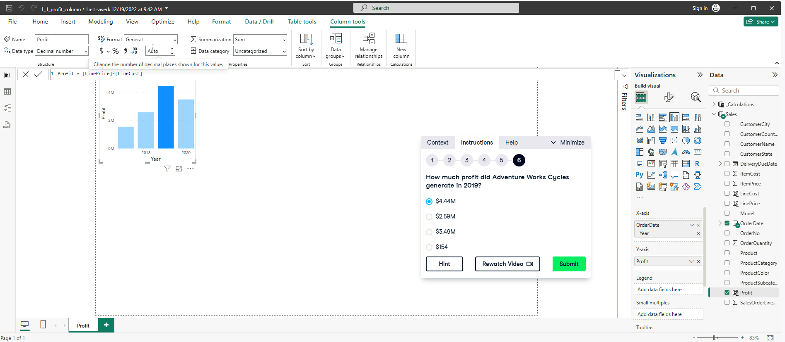

**Exercise 1.2**

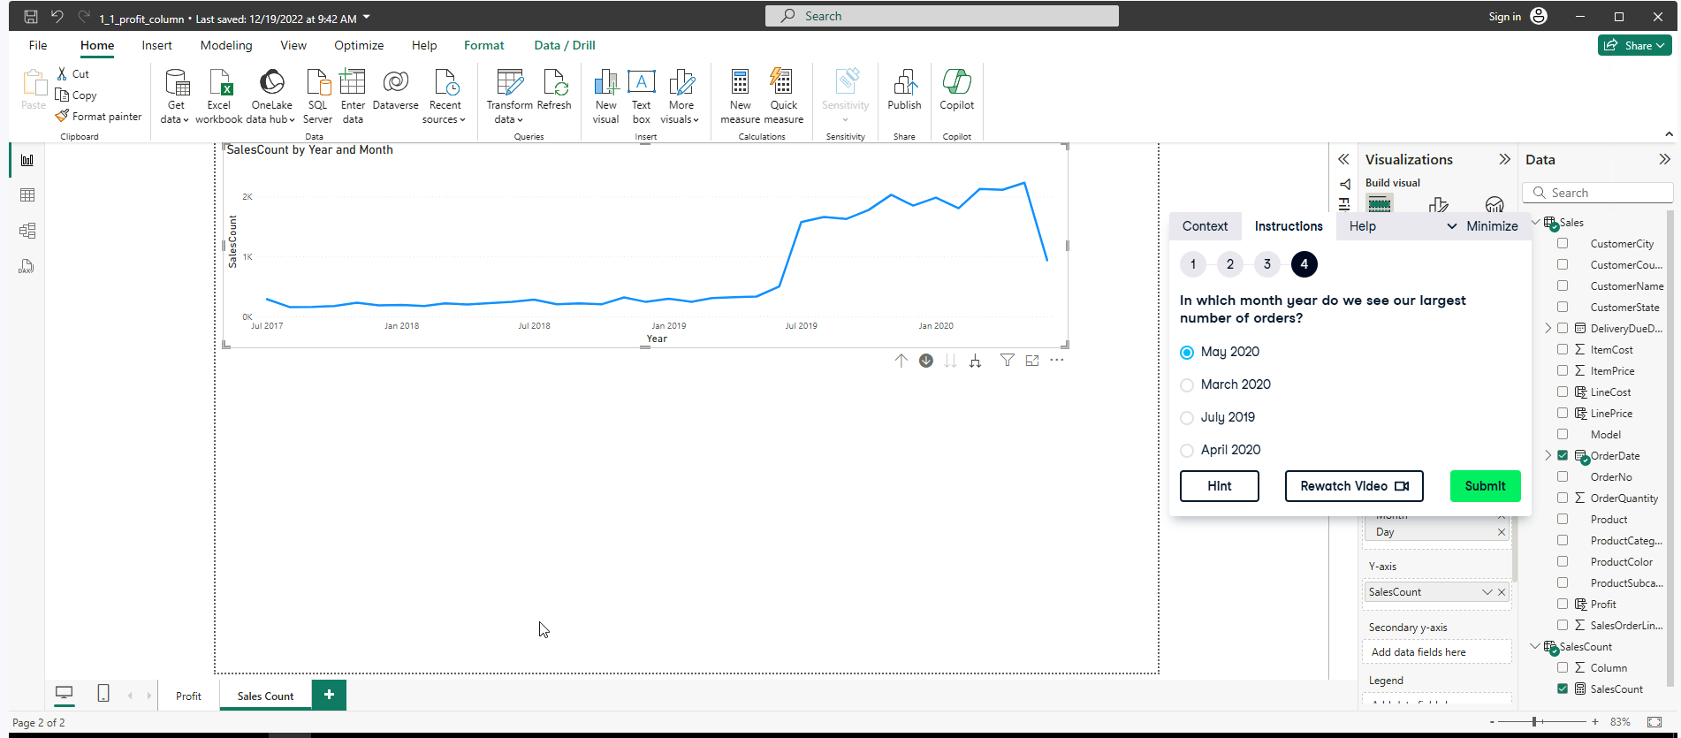

**Exercise 1.3**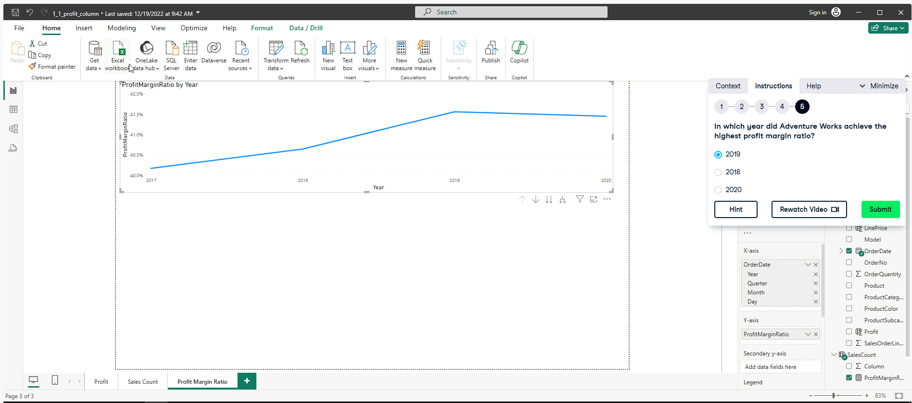

1. **Context in DAX Formulas**

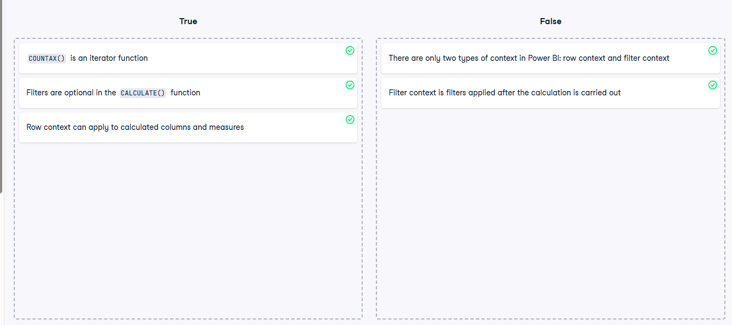

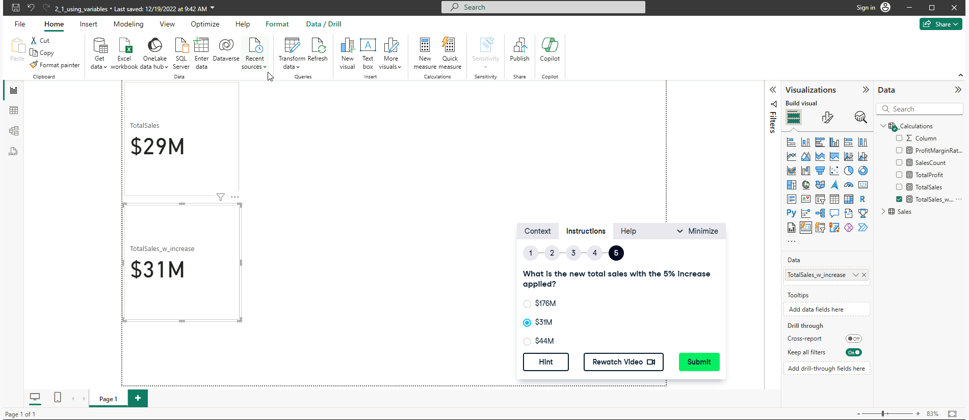**Exercise 2.1**

**A simple "What-if" or Margin/Forecasting Calculation** measure.

Measure =

VAR increase = 0.05

RETURN 'Calculations'[TotalSales] + ('Calculations'[TotalSales] * increase)

Main takeaways:

Calculates the arithmetic mean of a **column**.

AVERAGE(<column>)

Calculates the arithmetic mean by **evaluating an expression for each row** in a table and then averaging the results.

AVERAGEX(<table>, <expression>)

| **Feature** | **AVERAGE()** | **AVERAGEX()** |
| --- | --- | --- |
| Input | A single column | A table and an expression |
| Calculation Method | Direct average of column values | Row-wise evaluation, then average |
| Flexibility | Less flexible | Very flexible for calculated expressions |
| Performance | Generally faster | Slightly slower but more powerful |

**Exercise 2.3**

**Understanding the CALCULATION FUNCTION**

**NOTE || is AND**

[**CALCULATE function (DAX) - DAX | Microsoft Learn**](https://learn.microsoft.com/en-us/dax/calculate-function-dax)

[**Filter Arguments in CALCULATE - SQLBI**](https://www.sqlbi.com/articles/filter-arguments-in-calculate/)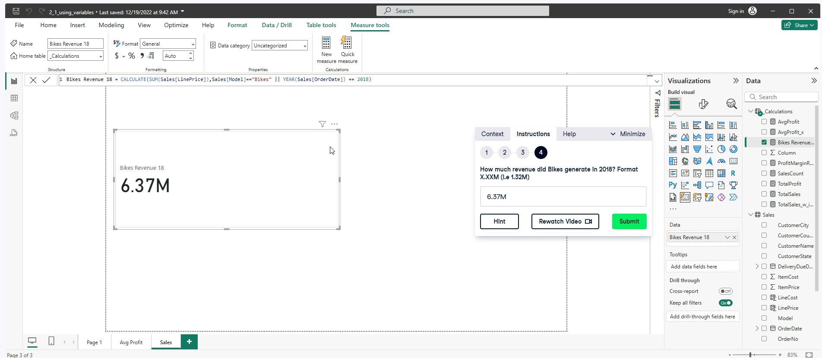

**Working with Dates**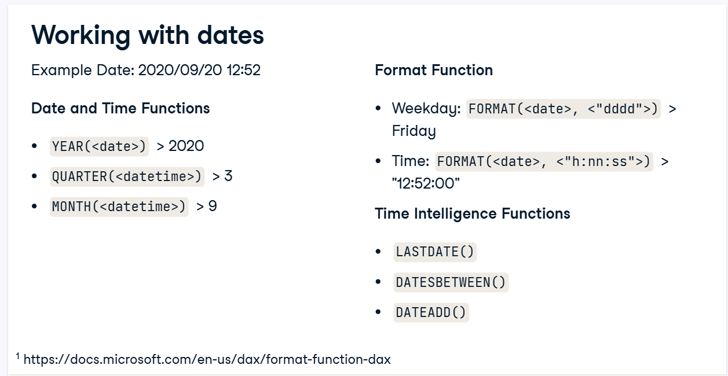

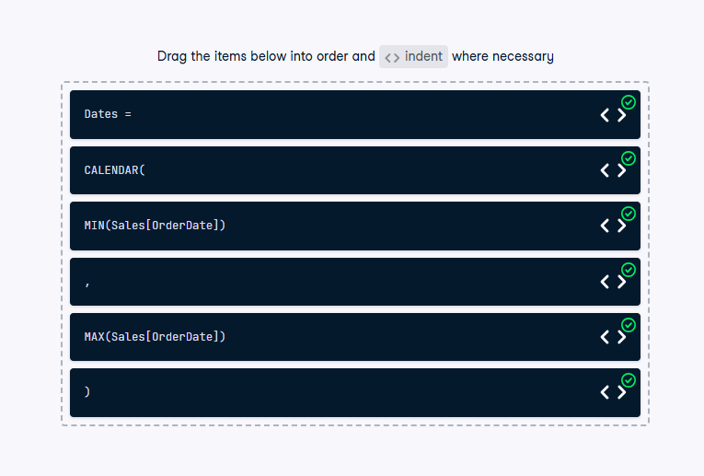

**Exercise 3.1**

[**CALENDAR function (DAX) - DAX | Microsoft Learn**](https://learn.microsoft.com/en-us/dax/calendar-function-dax)

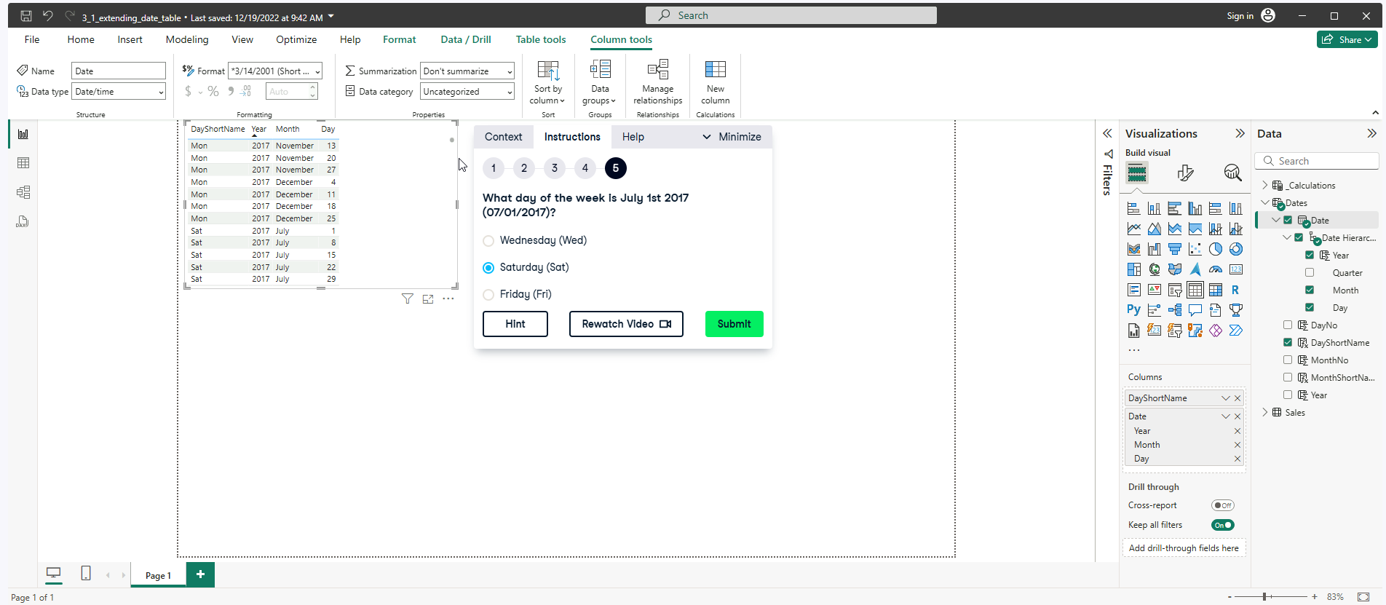

**Format function () seen above.**

**Exercise 3.2**

**Order2Delivery = DATEDIFF(Sales[OrderDate], Sales[DeliveryDueDate],DAY)**

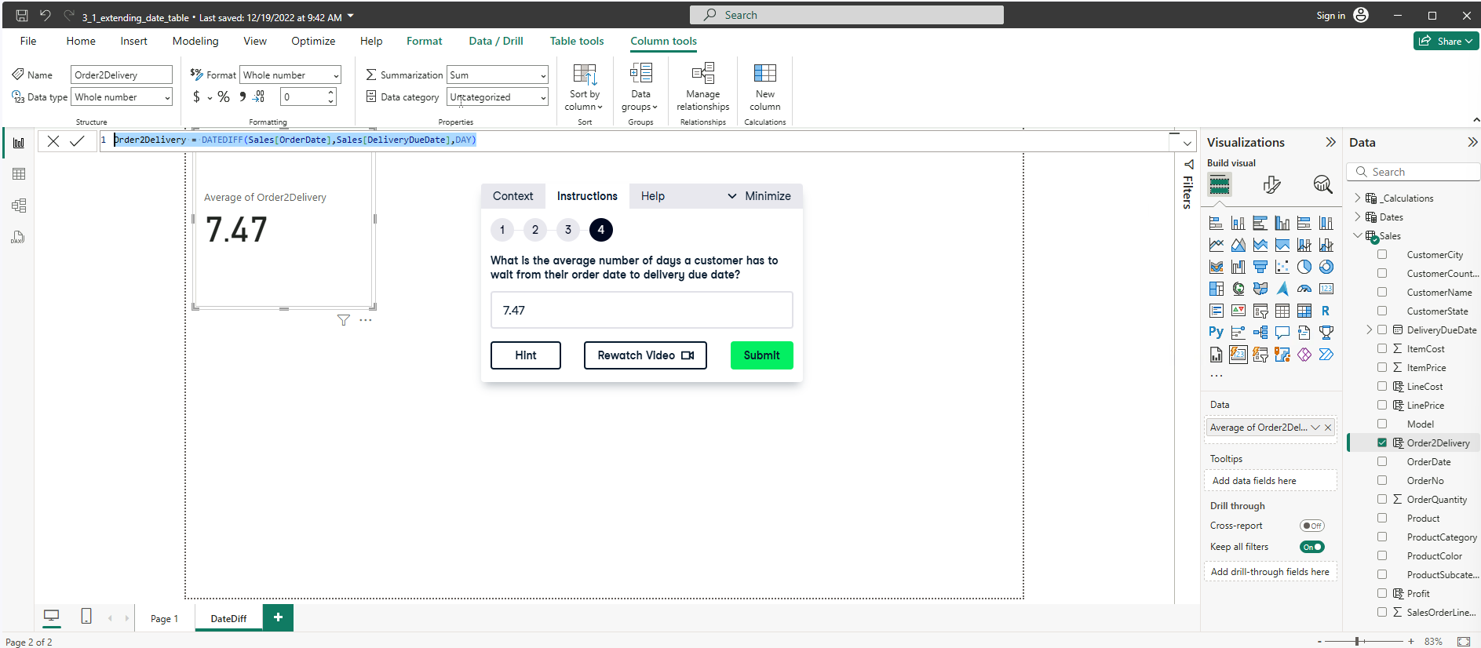

**Exercise 3.3**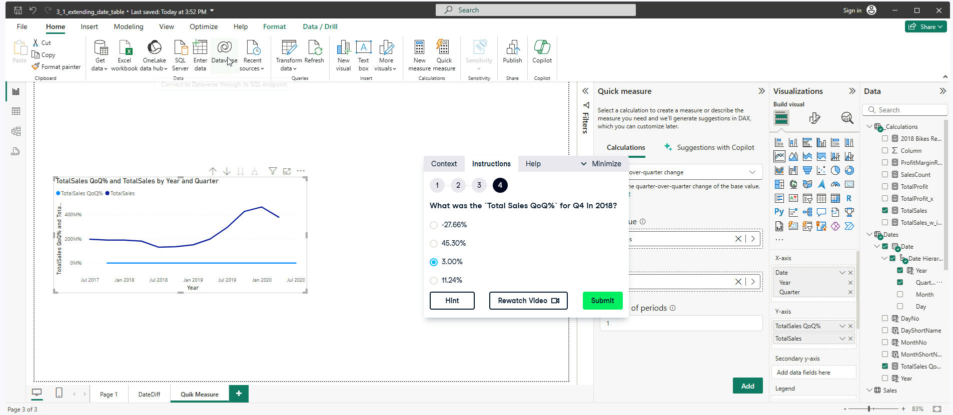

**Understanding the quick measure.**

